A LIBRARY MANAGMENT SYSTEM

SE112

2023-2024 Academic Semester

GROUP NO: 30

TEAM MEMBERS: Aleyna Dikmen 23244710049 Ahmet Kağan Doğan 20244710043

Çağatay Uğurlu 23244710040

CONTENSTS

Cover Page

Project Proposal 1

Project Management 2

Project Plan 2

Risk Plan 3

# 1.PROJECT PROPOSAL

Vision/What?

Our project endeavors to modernize library management practices through the development of an innovative web-based library management system. This system will serve as a dynamic hub for administrators, staff, and users, providing seamless access to library resources and integrating state-of-the-art technologies to enhance functionality and user experience.

Purpose/Why?

Traditional library management systems often encounter limitations in terms of accessibility and user engagement. Our project aims to overcome these challenges by introducing groundbreaking features enabled by innovative technologies. By offering intuitive interfaces, personalized recommendations, and streamlined processes, we seek to transform the library experience, making it more efficient, interactive, and enjoyable for all stakeholders.

Software Development Methodology/How?

To achieve our objectives, we will employ an agile software development methodology. Agile methodologies emphasize adaptability, collaboration, and iterative development, allowing us to respond swiftly to evolving requirements and stakeholder feedback. By breaking the project into manageable sprints, we can prioritize key features, maintain a high level of transparency, and deliver continuous value to users throughout the development process. This approach ensures that our final product meets the evolving needs and expectations of the library community.

# 2.PROJECT MANAGEMENT

2.1 PROJECT PLAN

Library Management System

Project Overview:

Develop a web-based library management system incorporating innovative technologies to enhance accessibility, efficiency, and user experience.

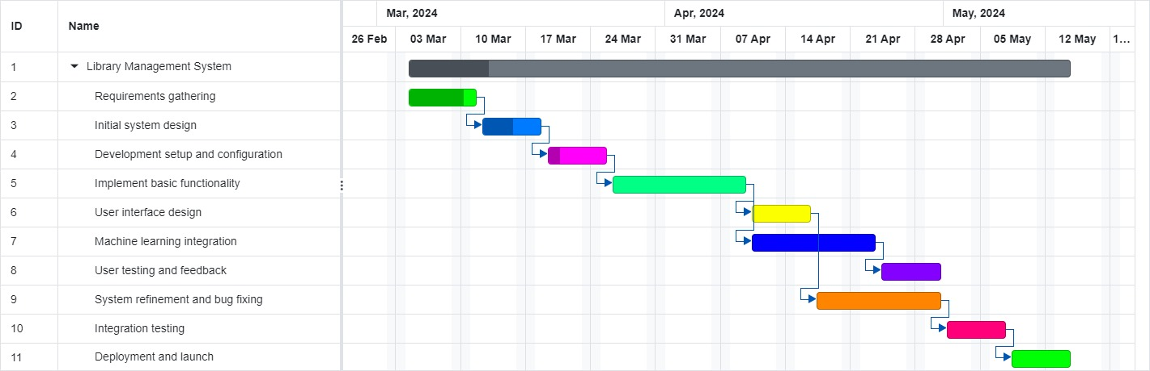

Project Objectives:

Create a modern, user-friendly interface for library staff and patrons.

Implement features such as personalized recommendations and advanced search capabilities.

Utilize innovative technologies (e.g., machine learning, cloud computing) to enhance functionality.

Ensure scalability, reliability, and security of the system

2.2 RISK PLAN

Risk 1: Integration Complexity

B-Plan: Develop a modular architecture to facilitate easier integration of innovative technologies. Prioritize the identification and resolution of integration challenges during the development phase. Establish clear communication channels with technology providers or experts to seek timely assistance in resolving integration issues. Maintain a contingency budget and timeline buffer to accommodate unforeseen delays or complications related to technology integration. Regularly review and adjust the integration strategy based on emerging challenges and feedback from stakeholders.

Risk 2: User Adoption and Training

B-Plan: Conduct comprehensive user training sessions prior to the system launch to familiarize library staff and patrons with the new system. Develop user-friendly interfaces with intuitive navigation to minimize the learning curve for users. Implement feedback mechanisms to gather user insights and address usability issues promptly. Provide ongoing support and assistance to users through helpdesk services, online resources, and user community forums. Collaborate with library administrators to promote the benefits of the system and encourage active user participation through incentives and rewards programs.